1.

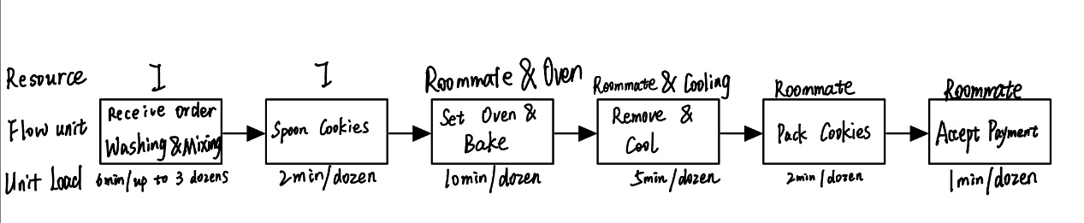

2.1

Washing & Mixing: 6 min / up to 3 dozens

Spoon Cookies: 2min / dozen

Set Oven & Bake: 10min / dozen

Remove & Cool: 5min / dozen

Pack Cookies: 2min / dozen

Accept Payment: 1min / dozen

2.2

I and my roommate operate the process. I operate the *Washing* & *Mixing* and *Spoon* *Cookies* part *Set* *Oven* & *Bake* need both roommate and oven, 1 minute for roommate and the other 9 minutes for oven. *Remove* step needs roommate and *Cool* step need time for cooling. The *pack cookies* and *accept* *payment* step needs only Roommate

2.3

Washing & Mixing: 0.5 dozen per minute

Spoon Cookies: 0.5 dozen per minute

Set Oven & Bake: 0.1 dozen per minute

Remove & Cool: 0.5 dozen per minute

Pack Cookies: 0.5 dozen per minute

Accept Payment: 1 order per minute

Resource:

I: 15 dozen per hour.

Roommate and Oven: 6 dozen per hour.

Roommate and Cooling: 12 dozen per hour.

Roommate: 20 dozen per hour.

2.4

*Set Oven & Bake* takes 10 minutes per dozen, making it the most time-consuming process. So, the bottleneck is *Set Oven & Bake.*

3.1

The theoretical time should be flow time.

Total time = 6 + 2 + 10 + 5 + 2 + 1 = 26 min

If the oven is occupied, the total time could be extended.

3.2

For n dozens of cookies, the additional time should be cycle time of the process. Assuming the rush order contains n dozens of cookies’ need, the total time should be:

26 + 10(n – 1) = 16 + 10n (minutes)

4.

For the first order, the total time is 26 minutes. For every new order except the first, we need cycle time to bake another dozen of cookies. Cycle time is 10 minutes / dozen. So, we can fill in 22 orders in four hours. ((4 \* 60 – 26) / 10 + 1 = 22.4). We can fill in 25 orders in four and a half hours. ((4.5 \* 60 – 26) / 10 + 1 = 25.4)

5.

The capacity rate of the process grows. The capacity rate of *Set Oven & Bake* grows up to 12 dozen per hour (used to be 6). The capacity rate of the process grows up to 12 dozen per hour. The cycle time is reduced to 5 minutes per dozen of cookies. However, the flow time will not change.

Assuming a four hours’ night opening for selling cookies. The new cycle time is 5 minutes. So we can fill in 43 orders((240 – 26) / 5 + 1 = 43.8). The marginal profit is the profit of 21 orders. The marginal cost is $0.7 per dozen. Assuming the price is x dollars per dozen. The maximum price I will rent oven is 21\*(x – 0.7) dollars. For example, if the x equals 1, I will pay for the rent as long as the rent price is lower than $6.3. Whether rent or not does not matter if the rent price is $6.3. For price higher that $6.3, I will not consider about.

6.

Assuming the order needs k dozens of cookies.

RM : 3k + 1

I: 6 + 2k for k < 3.

for k >= 3, k = 3p + q（p = k//3, q = k % 3）

total time: 12 mins \* p + 6 + 2\*q